CRM Application for Banquet Hall Booking
Use Case
Banquet hall booking is the process of reserving a venue for events such as weddings, corporate functions, birthday parties, and other special occasions.
The process begins when a client submits an inquiry about the availability of the banquet hall for a specific date and event type. The client then shares their requirements, including event date, number of guests, seating layout, catering preferences, and any additional requests.
Based on these requirements, the banquet hall provides a proposal that includes available packages, pricing details, services, and amenities.
Once the booking is confirmed, an event coordinator collaborates with the client to finalize all event details. This includes seating arrangements, menu selection, decorations, audiovisual setup, and other custom requirements.
On the event day, the banquet hall team ensures smooth execution, handles any issues, and supports the client and guests throughout the event.

Project Overview
This project aims to develop a CRM-based booking management system for a banquet hall business using Salesforce.
The system will:
- Streamline the booking and inquiry process
- Manage event details and client requirements
- Track sales, bookings, and revenue insights
- Support catering and menu selection
- Manage additional services such as DJ, decorations, and wedding themes
- Handle marriage-related and custom event services
Additionally, automation flows will be implemented to:
- Maintain data integrity
- Prevent double bookings
- Ensure efficient coordination between teams

Project Flow:

Milestone 1: Salesforce Developer Account SetUp
Milestone 2: Object
Milestone 3: Tabs
Milestone 4: The Lightning App
Milestone 5: Fields & Relationship
Milestone 6: Creation of Page Layouts
Milestone 7: Creation of Record Types
Milestone 8: Validation rules
Milestone 9: Flows
Milestone 10: Triggers
Milestone 11: Reports
Milestone 12: Dashboards

Introduction
Are you new to Salesforce and unsure what it is or how to get started? If so, this guide will help you understand the basics and begin your learning journey.
Salesforce is a powerful platform that improves productivity and helps businesses manage their operations more efficiently. It provides tools that enable users to sell faster, work smarter, and maintain better relationships with customers.

What is Salesforce?
Salesforce is a customer success platform designed to support key business functions, including sales, service, marketing, analytics, and customer engagement.
It allows organizations to:
- Manage relationships with prospects and customers
- Track communications such as emails and follow-ups
- Collaborate with team members and partners
- Store and access data securely in the cloud
Salesforce enables businesses to operate from anywhere by using centralized, cloud-based tools. Before using Salesforce, information like contacts, tasks, emails, and sales opportunities was often scattered across multiple systems or stored manually, making it harder to manage and track efficiently.

- Milestone 1: Salesforce Developer Account SetUp
Activity 1: Creating Developer Account:
Description
- Creating a developer org in salesforce.
- Go to https://developer.salesforce.com/signup
- On the sign up form, enter the following details :
- First name & Last name
- Email
- Job Title: Developer
- Company : College Name
- County : India
Click on sign me up after filling these.
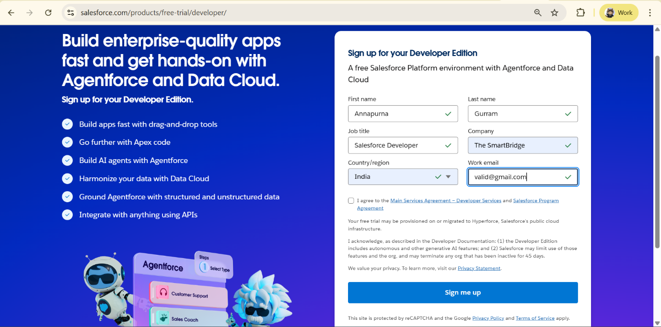
Activity 2: Account Activation
Description
1. Go to the inbox of the email that you used while signing up. Click on the verify account to activate your account. The email may take 10-30 mins and sometimes 2 hours.
2. Click on Verify Account
3.Give a password and answer a security question and click on change password.
4.Then you will redirect to your salesforce setup page.
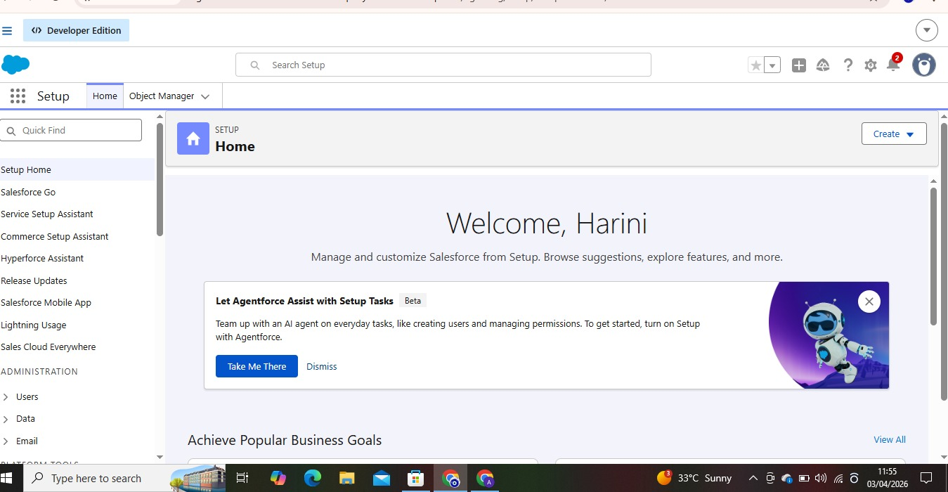
- Milestone 2: Object
What is an object?
Salesforce objects are database tables that permit you to store data that is specific to an
organization. It consists of fields (columns) and records (rows).
Custom Objects Created:
- Banquet Hall – Stores Banquet Hall Booking Information
- Billing – The Billing information of the related Bookings
- Staff– maintains Complete Staff information related to Banquet Hall
Activity 1: Creating 3 Objects
Description
- Creating a Banquet Hall Object
- The purpose of creating a Banquet Hall custom object is to store and manage information about Banquet Hall Bookings.
- To create an object:
- From the setup page
- Click on Object Manager
- Click on Create → Click on Custom Object.
- Enter the label name→ Banquet Hall
- Enter Plural label name→Banquet Halls
- Enter Record Name → Customer Name
- Select Data Type as Text.
- Select Allow reports.
- Select Allow search.
- Click on Save and New

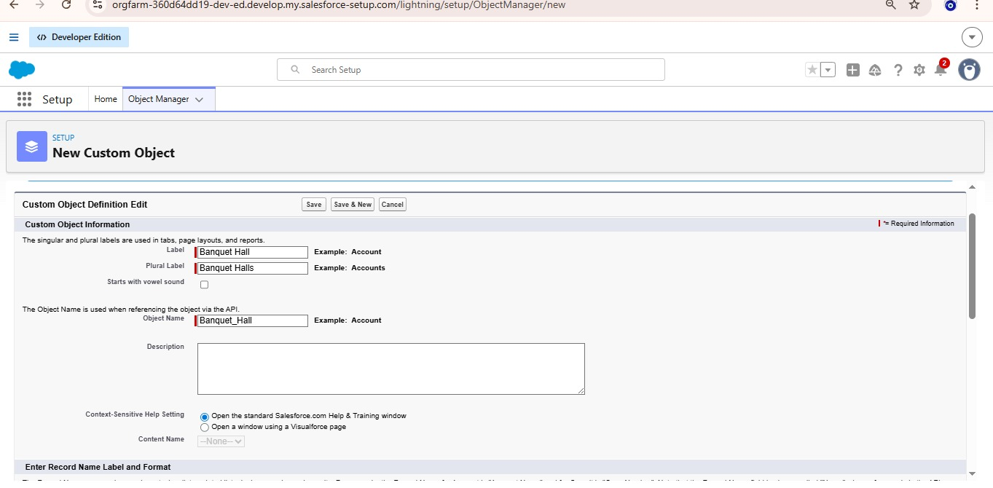

- Milestone 3: Tabs
What is Tab:
A tab is like a user interface that is used to build records for objects and to view the records in the objects.
Activity 1: Creating a tab for Banquet Hall Object
Description
- Go to the setup page → type Tabs in Quick Find bar
- Click on tabs
- Click on New (under custom object tab).
- Select Object(Banquet Hall) → Select the tab style
- Click on Next →(Add to profiles page) keep it as default →Click on Next (Add to Custom App) uncheck the include tab .
- Make sure that the Append tab to users' existing personal customizations is checked.
- Click save
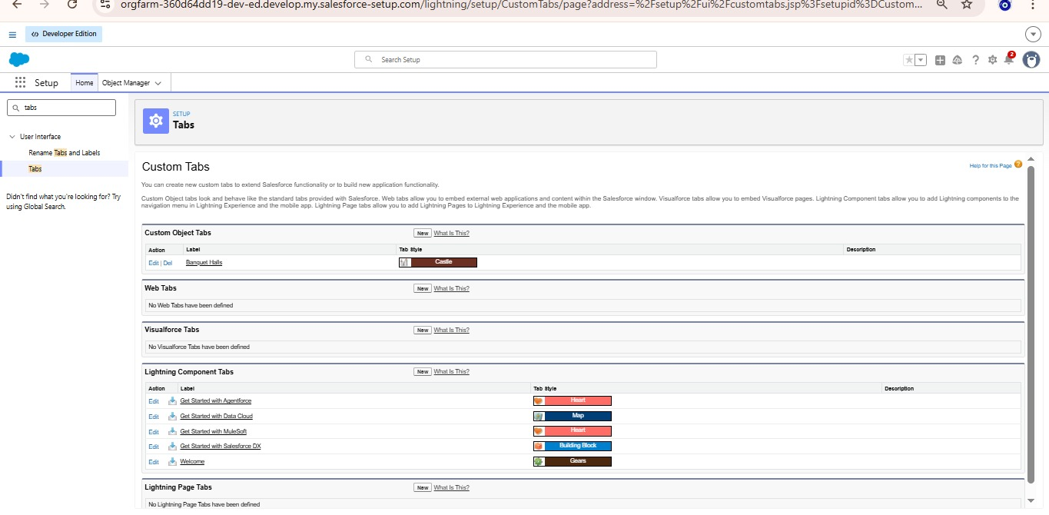

Activity 2: Creating Remaining Tabs
Description
- Now create the Tabs for the remaining Objects, they are “Billing, Staff”.
- Follow the same steps as mentioned in Activity -1 .
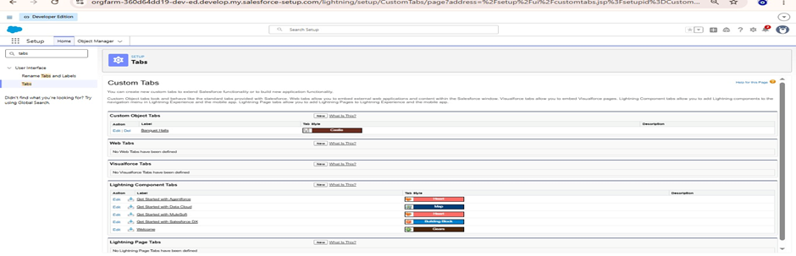
- Milestone 4: The Lightning App
What Is a Lightning App?
A Lightning App in Salesforce is a custom collection of tabs, objects, and features that shows users exactly what they need for their job — in a branded, streamlined workspace using the Lightning Experience UI.
Activity 1: Create a Lightning App for Banquet Hall Booking
Description
- From Setup, enter App Manager in the Quick Find and select App Manager.
- Click New Lightning App.
- Enter Banquet Hall Booking as the App Name, then click next
- Under App Options, leave the default selections and click next.
- Under Utility Items, leave as is and click Next.
- From Available Items, select Banquet Halls, Billings, Staff, Reports, and Dashboards and move them to Selected Item and Click Next.
- From Available Profiles, select System Administrator and move it to Selected Profiles.
- Click Save & Finish.
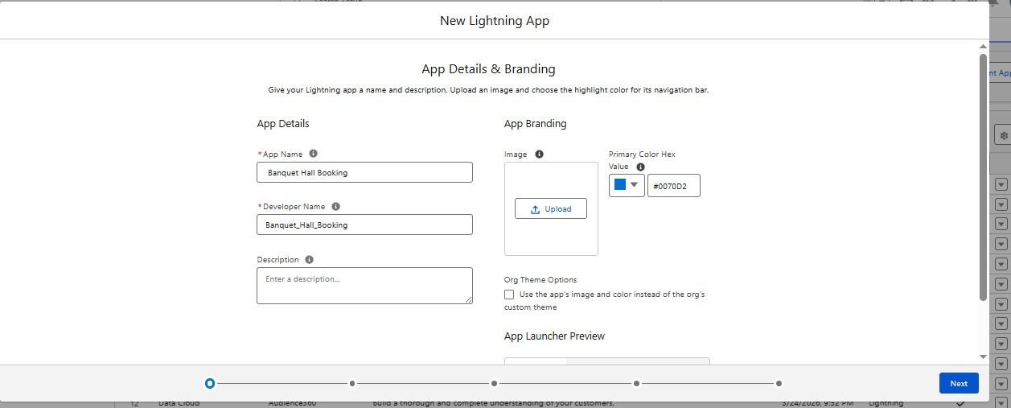
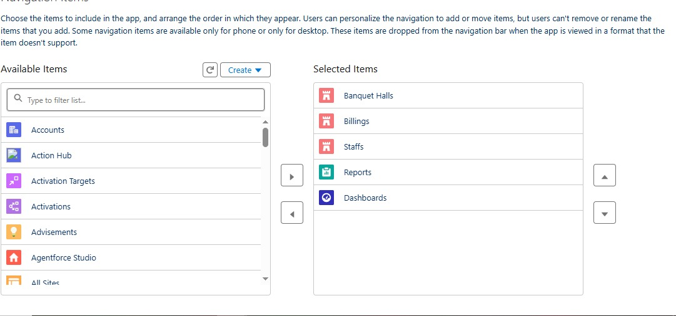
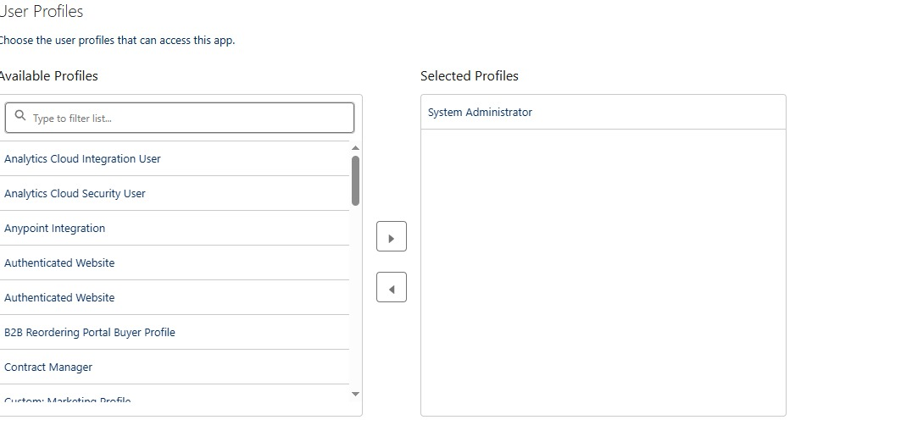

- Milestone 5: Fields & Relationship
Activity 1: Creating a PickList Field in Banquet Hall
Description
- To create fields in an object:
- Go to setup → click on Object Manager → type object name(Banquet Hall) in quick find box→ click on the Banquet Hall object.
- Now click on “Fields & Relationships”
- Click on New.
- Select Data type as “Picklist” and click Next.
- Enter Field Label as “Timings”.
- In values select “Enter values(Morning, Evening), with each value separated by a new line" and enter values as shown below.
- Select Required, Always require a value in this field in order to save a record .
- Click on Next, Next and Save.

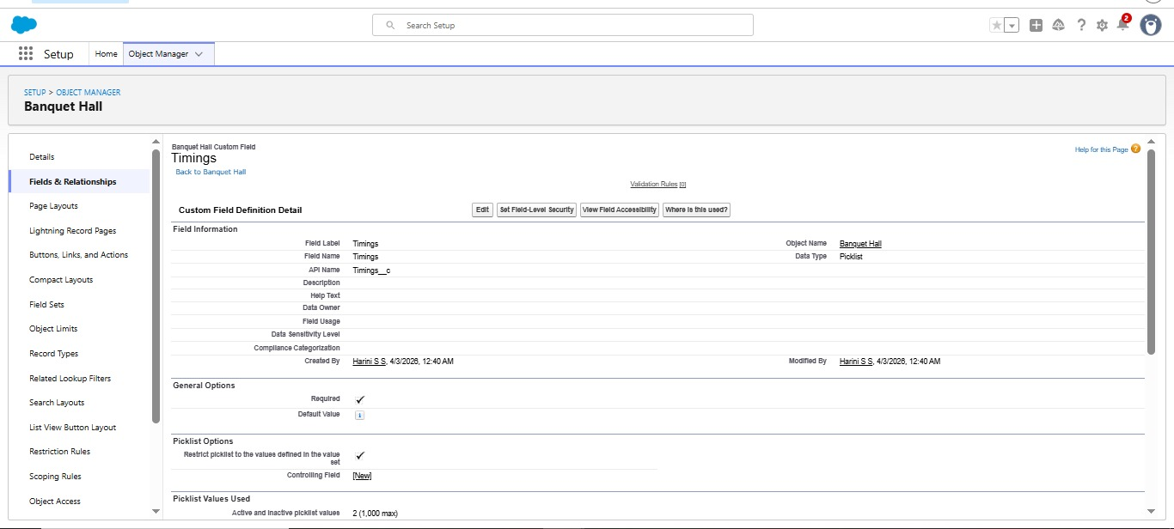

Activity 2: Creating a Date Field in Booking Hall object
- Go to setup → click on Object Manager → type object name(Banquet Hall) in quick find box→ click on the Banquet Hall object.
- Now click on “Fields & Relationships”
- Click on New.
- Select Data type as “Date” and click Next.
- Enter Field Label as “ Booking Date”.
- Select Required, Always require a value in this field in order to save a record .
- Click on Next, Next and Save.


Activity 3:Creating a Number Field in Banquet Hall object
- Go to setup → click on Object Manager → type object name(Banquet Hall) in quick find box→ click on the Banquet Hall object.
- Now click on “Fields & Relationships”
- Click on New.
- Select Data type as “Number” and click Next.
- Enter Field Label as “ No of Visitors”.
- Length - 18, Decimal Places - 0.
- Select Required, Always require a value in this field in order to save a record .
- Click on Next, Next and Save.
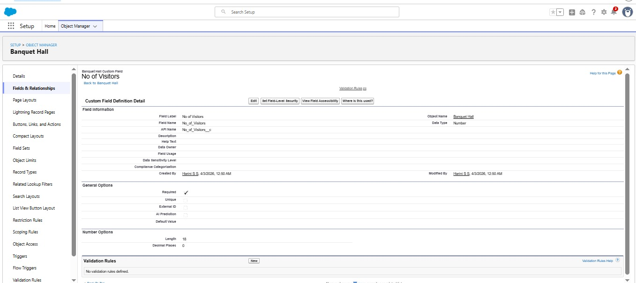

Activity 4 : Creating Master Detail Relationship
To Create a relationship between Banquet Hall & Billing Objects.
- Go to the Setup page → click on Object manager → type object name(Billing) in the quick find bar→ click on the object.
- Click on fields & relationship
- Click on New.
- Select “Master Detail relationship” as data type and click Next.
- Select the related object “ Banquet Hall”.
- Click on Next
- Give Field Label as “Customer Name” .
- Click on Next → Next → Next → Save.
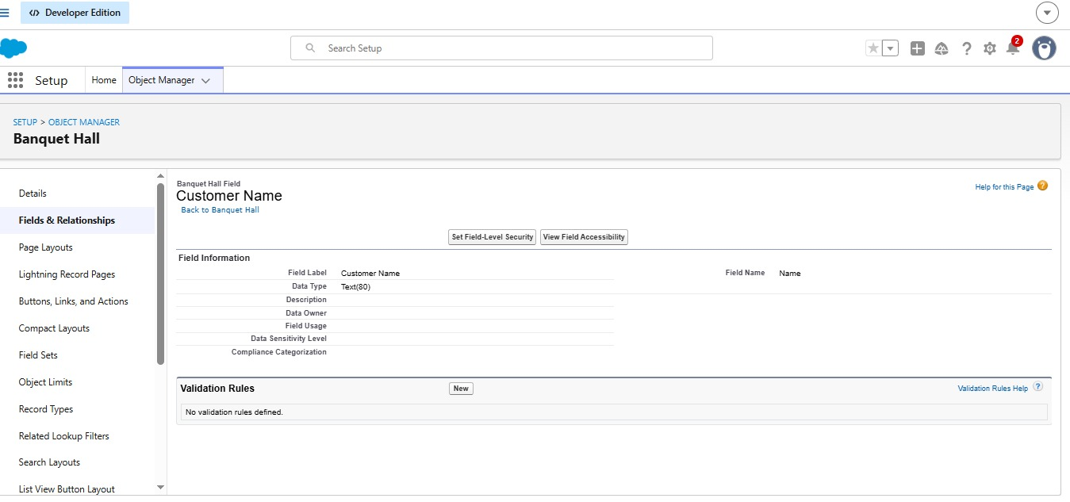
Activity 5: Creating a Checkbox Field in Banquet Hall object
- Go to setup → click on Object Manager → type object name(Banquet Hall) in quick find box→ click on the Banquet Hall object.
- Now click on “Fields & Relationships”
- Click on New.
- Select Data type as “Checkbox” and click Next.
- Enter Field Label as “ DJ”.
- Select Default value : Unchecked .
- Click on Next, Next and Save.
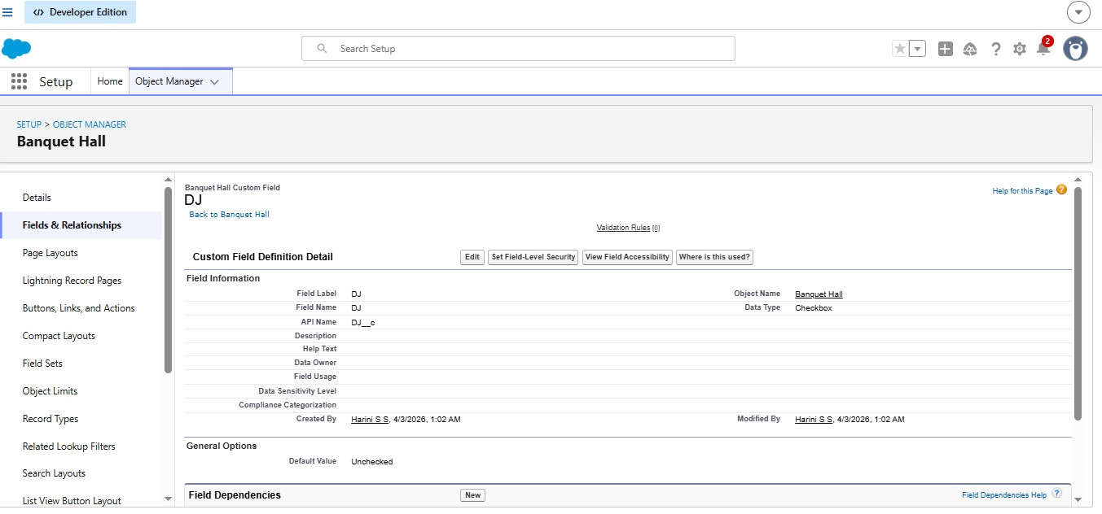

Activity 6: Creating a Phone Field in Banquet Hall object
- Go to setup → click on Object Manager → type object name(Banquet Hall) in quick find box→ click on the Banquet Hall object.
- Now click on “Fields & Relationships”
- Click on New.
- Select Data type as “Phone” and click Next.
- Enter Field Label as “ Phone No”.
- Click on Next, Next and Save.
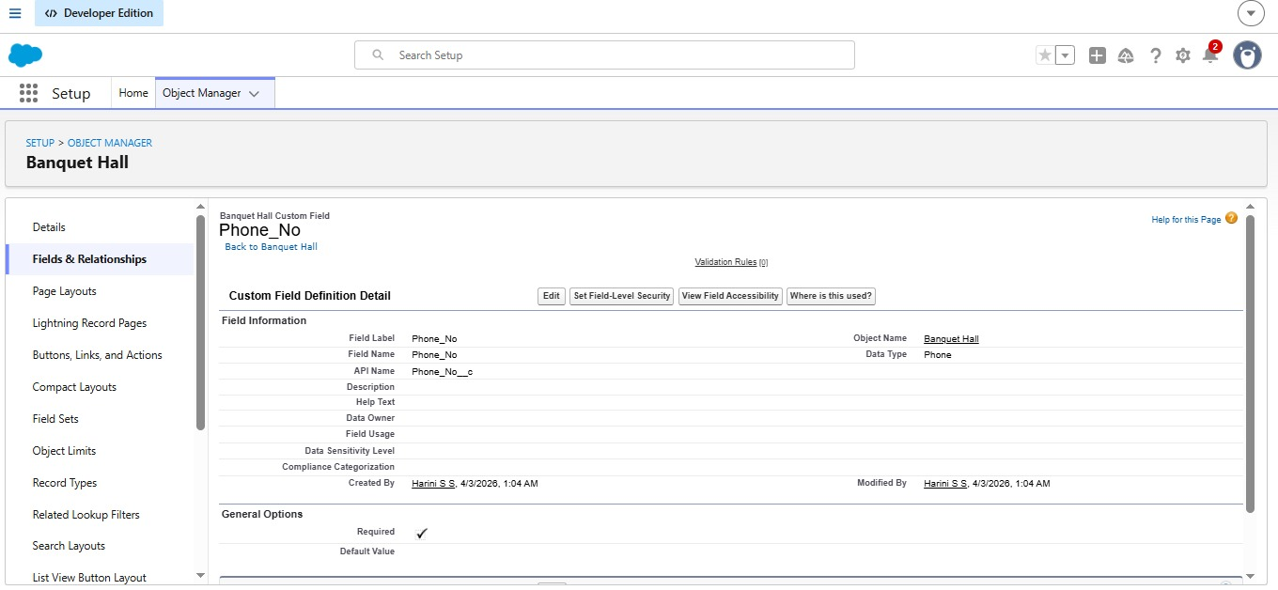
Activity 7: Creating a Archestra Amount Formula Field in Billing object
- Go to setup → click on Object Manager → type object name(Billing) in quick find box→ click on the Billing object.
- Now click on “Fields & Relationships” Click on New.
- Select Data type as “Formula” and click Next.
- Enter field label Archestra Amount
- Select formula return type Currency, Click Next
- Create and insert Advance formula: IF( Customer_Name__r.Archestra__c = TRUE, 50000, 0)
- Click Next, Next, then Save
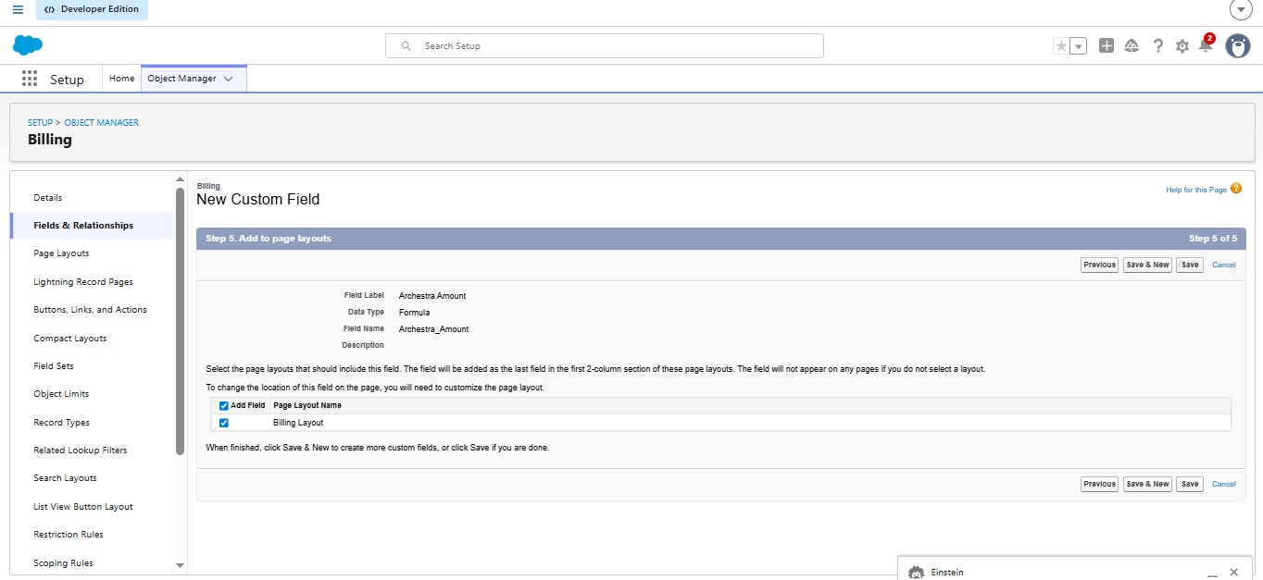

Activity 8:Creating a DJ Amount Formula Field in Billing object
- Go to setup → click on Object Manager → type object name(Billing) in quick find box→ click on the Billing object.
- Now click on “Fields & Relationships”
- Click on New.
- Select Data type as “Formula” and click Next.
- Enter field label DJ Amount
- Select formula return type Currency, Click Next
- Create and insert Advance formula: IF( Customer_Name__r.DJ__c = TRUE, 70000, 0)
- Click Next, Next, then Save.

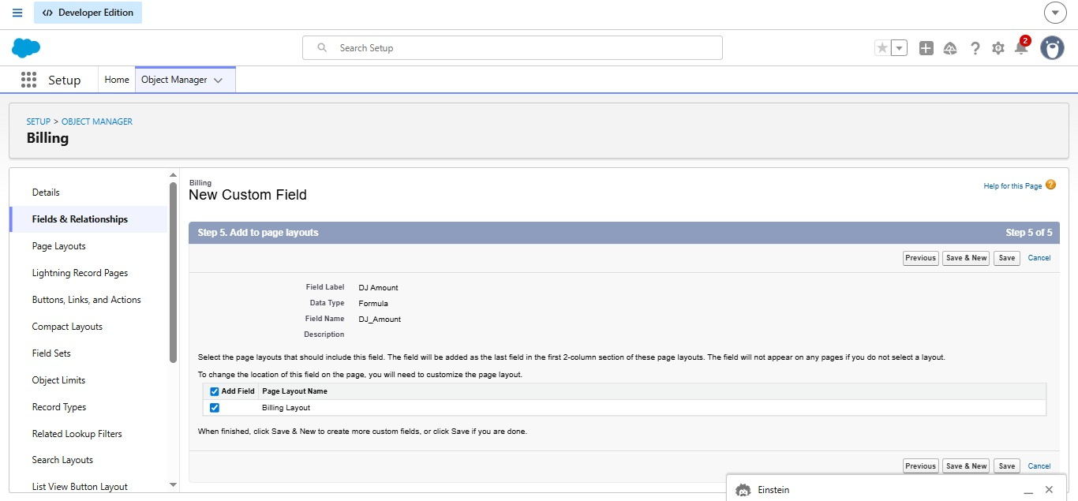

Activity 9: Creating a Magician Amount Formula Field in Billing object
Description
- To create fields in an object:
- Go to setup → click on Object Manager → type object name(Billing) in quick find box→ click on the Billing object.
- Now click on “Fields & Relationships”
- Click on New.
- Select Data type as “Formula” and click Next.
- Enter field label Magician Amount Select formula return type Currency, Click Next
- Create and insert Advance formula: IF( Customer_Name__r.Magician__c , 15000, 0)
- Click Next, Next, then Save.
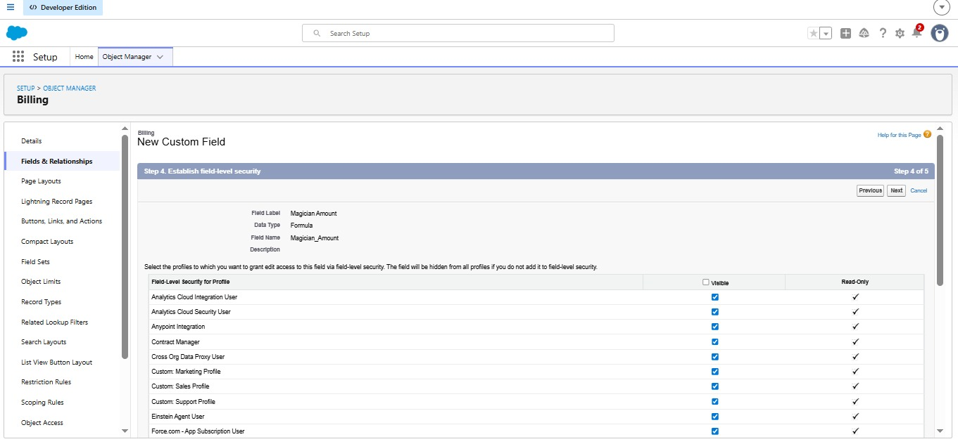

Activity 10: Creating a Shehnai and Mridangam Amount Formula Field in Billing
Description
- To create fields in an object:
- Go to setup → click on Object Manager → type object name(Billing) in quick find box→ click on the Billing object.
- Now click on “Fields & Relationships”
- Click on New.
- Select Data type as “Formula” and click Next.
- Enter field label Shehnai and Mridangam Amount Select formula return type Currency, Click Next
- Create and insert Advance formula: IF( Customer_Name__r.Shenai_and_Mridangam__c = TRUE, 25000, 0)
- Click Next, Next, then Save.

Activity 11: Creating a Kolatam Amount Formula Field in Billing object
- Go to setup → click on Object Manager → type object name(Billing) in quick find box→ click on the Billing object.
- Now click on “Fields & Relationships”
- Click on New.
- Select Data type as “Formula” and click Next.
- Enter field label Kolatam Amount.
- Select formula return type Currency, Click Next.
- Create and insert Advance formula: IF( Customer_Name__r.Kolatam__c , 15000, 0)
- Click Next, Next, then Save.

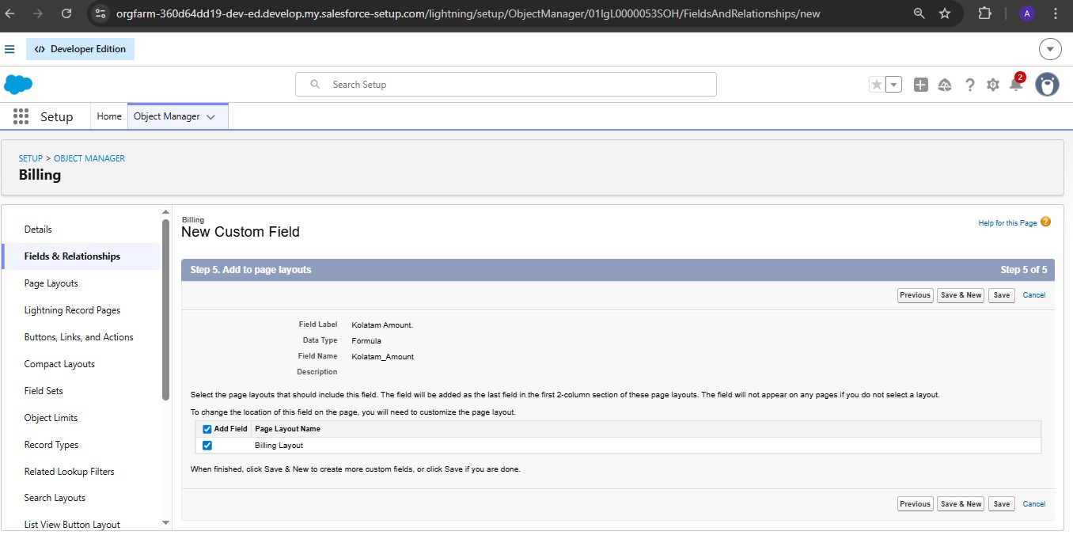

Activity 12: Creating a Food Amount per Plate Formula Field in Billing object
- Go to setup → click on Object Manager → type object name(Billing) in quick find box→ click on the Billing object.
- Now click on “Fields & Relationships”
- Click on New.
- Select Data type as “Formula” and click Next.
- Enter field label Food Amount per Plate
- Select formula return type Currency, Click Next
- Create and insert Advance formula as follows: CASE( Customer_Name__r.Food_Menu__c , 'Veg', 450, 'Special Veg', 550, 'Non-Veg', 550, 650)
- Click Next, Next, then Save.
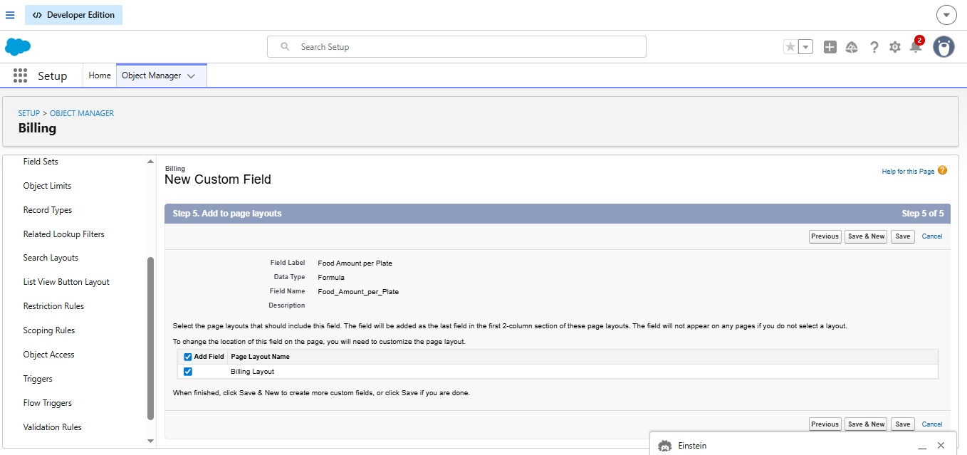

Activity 13: Creating a Food Amount Formula Field in Billing object
- Go to setup → click on Object Manager → type object name(Billing) in quick find box→ click on the Billing object.
- Now click on “Fields & Relationships”
- Click on New.
- Select Data type as “Formula” and click Next.
- Enter field label Food Amount.
- Select formula return type Currency, Click Next
- Create and insert Advance formula as follows: Food_Amount_per_Plate__c * Customer_Name__r.No_of_Visitors__c
- Click Next, Next, then Save.

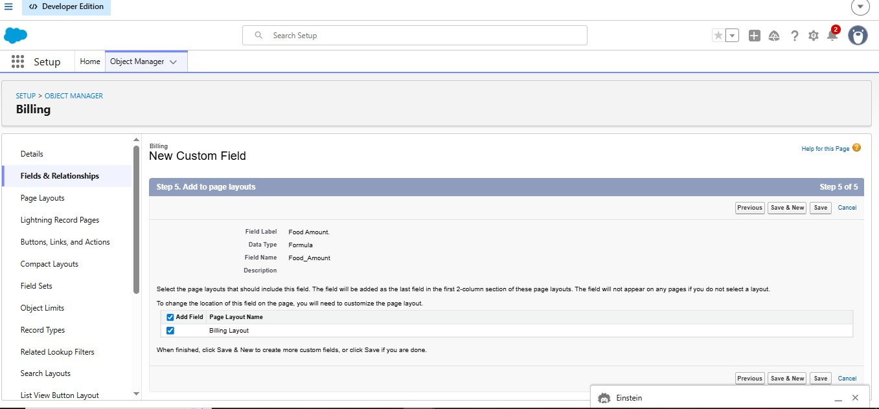

Activity 14: Creating a Decoration Amount Formula Field in Billing object
- Go to setup → click on Object Manager → type object name(Billing) in quick find box→ click on the Billing object.
- Now click on “Fields & Relationships”
- Click on New.
- Select Data type as “Formula” and click Next.
- Enter field label Decoration Amount.
- Select formula return type Currency, Click Next
- Create and insert Advance formula as follows: CASE( Customer_Name__r.Decoration_Purpose__c ,'Marriage', 50000, 'Reception', 60000, 'Anniversary', 30000, 'Birthday', 25000 , 'Other Events', 20000 , 0)
- Click Next, Next, then Save.
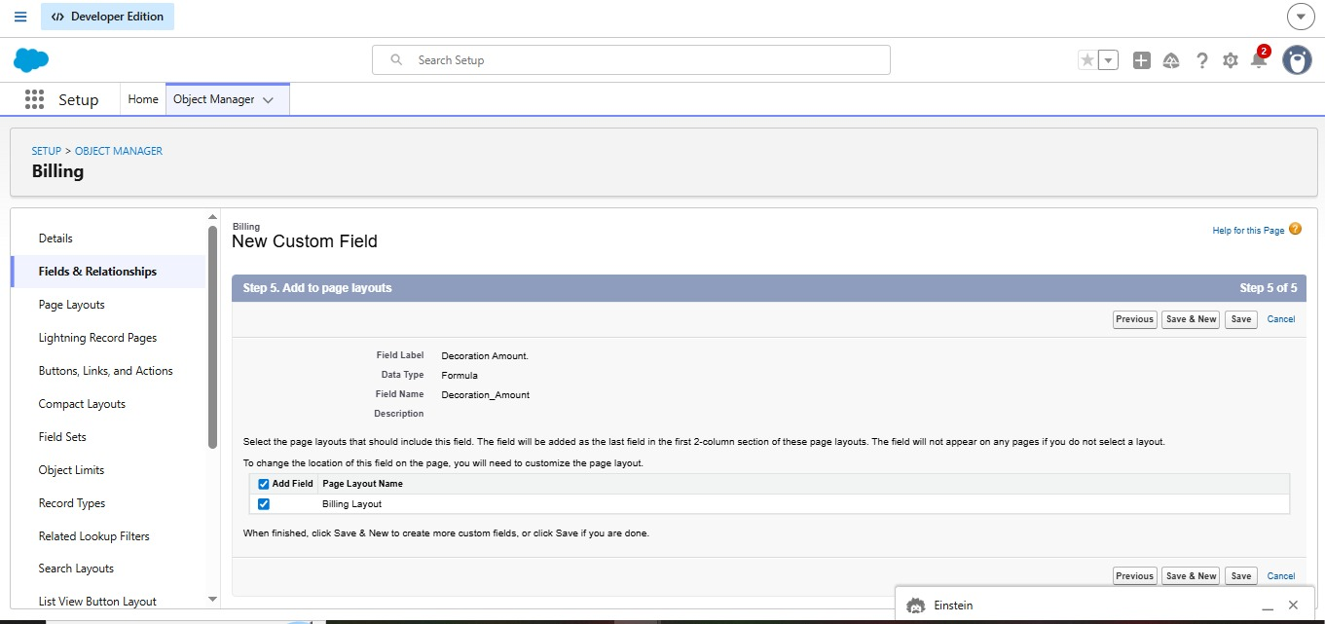

Activity 15: Creating a Email Field in Banquet Hall object
- Go to setup → click on Object Manager → type object name(Banquet Hall) in quick find box→ click on the Banquet Hall object.
- Now click on “Fields & Relationships”
- Click on New.
- Select Data type as “Email” and click Next.
- Enter the Field Label as “ Email”.
- Select Required
- Click Next, Next, then Save.
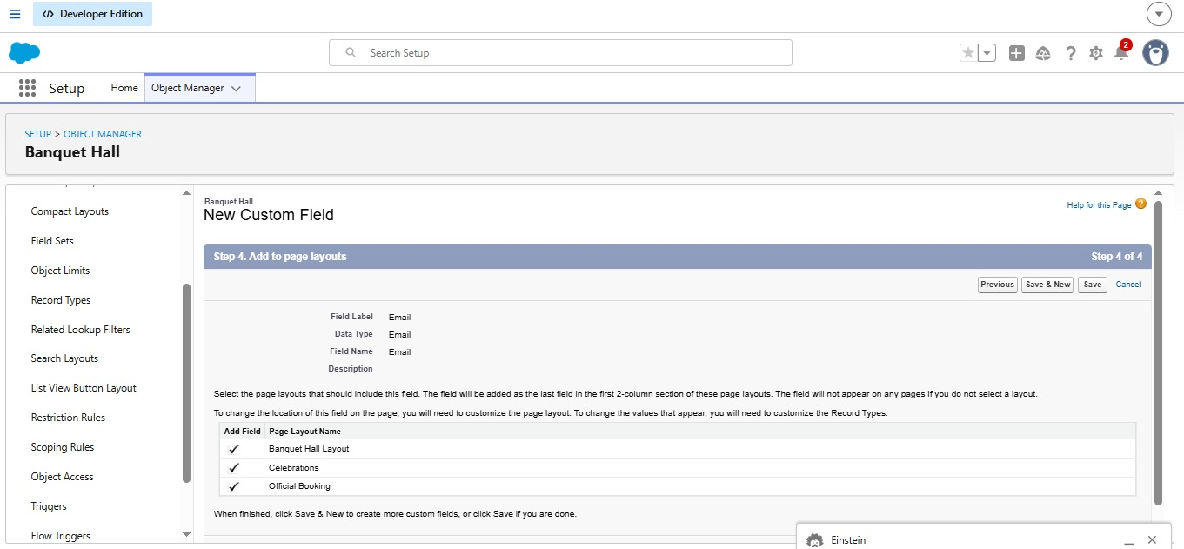
- Milestone 6: Creation of Page Layouts
A Page Layout in Salesforce controls how fields, sections, buttons, and related lists appear on a record detail and edit page.
It helps customize the user experience by showing only the relevant information based on business needs.
Activity 1: To create a Page Layout in Banquet Hall Object for Official Booking
Description
- Go to setup → click on Object Manager → type object name(Banquet Hall) in quick find box→ click on the Banquet Hall object.
- Click on the Page Layouts
- Click on New.
- Enter details as
- Existing Page Layout : Select Banquet Hall Layout
- Page Layout Name :Official Booking
- Click on Save
- Drag and Arrange the field as shown below
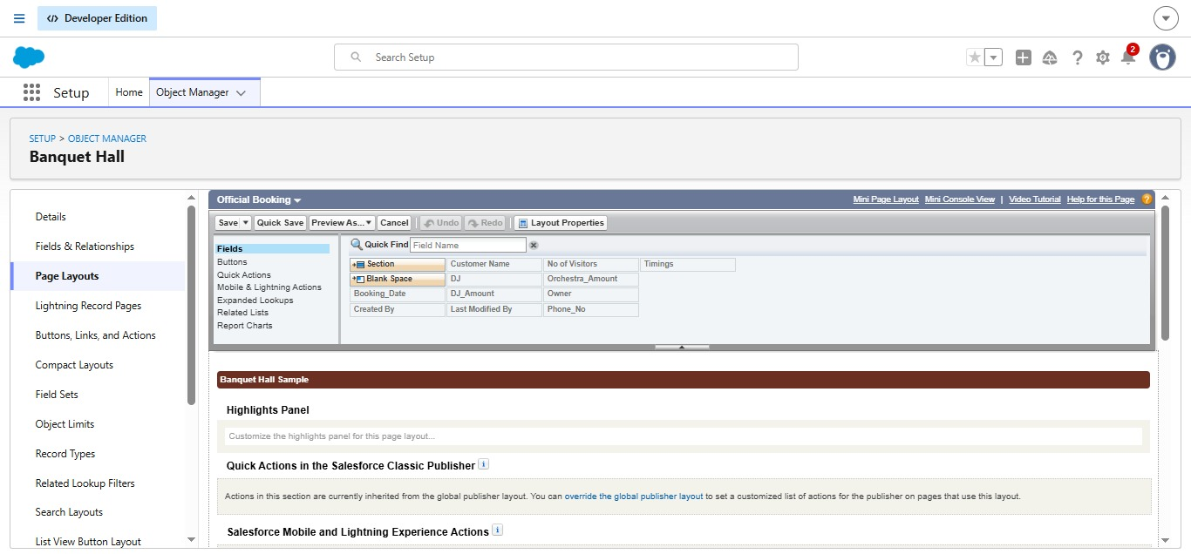

Activity 2: To create a Page Layout in Banquet Hall Object for Celebrations
- Go to setup → click on Object Manager → type object name(Banquet Hall) in quick find box→ click on the Banquet Hall object.
- Click on the Page Layouts
- Click on New.
- Enter details as
- Existing Page Layout : Select Banquet Hall Layout
- Page Layout Name : Celebrations
- Click on Save
- Drag and Arrange the field as shown below
- Click Save.
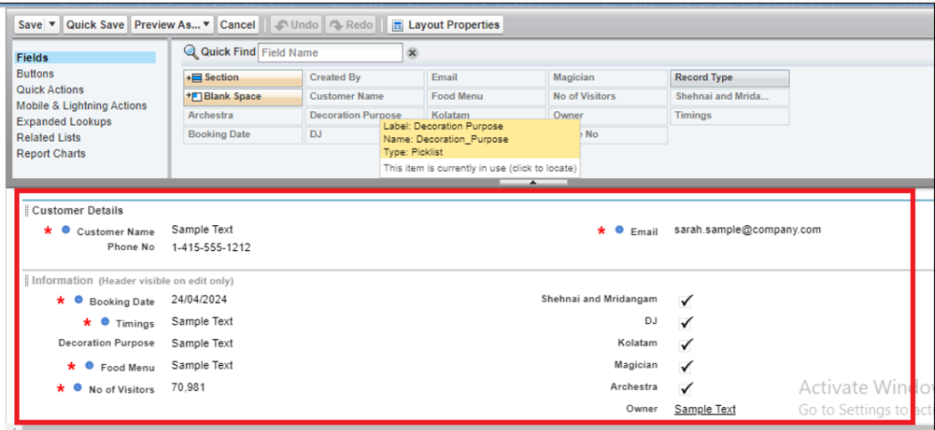
- Milestone 7: Creation of Record Types
Record Types in Salesforce allow you to define different business processes, picklist values, and page layouts for the same object.
They help support multiple use cases within a single object.

Activity 1: To create a Record Type for Official Booking in Banquet Hall Object
- Go to setup → click on Object Manager → type object name(Banquet Hall) in quick find box→ click on the Banquet Hall object.
- Click on the Record Types.
- Click on New.
- Enter the details : For Record Types
- Existing Record Types : Master
- Record Type Label : Official Booking
- Record Type Name : Official_Booking
- Active : Tick checkbox
4.Click on Next
- In Assign Page Layout
- Apply one layout to all profiles : Select Official Booking
- Click on Save

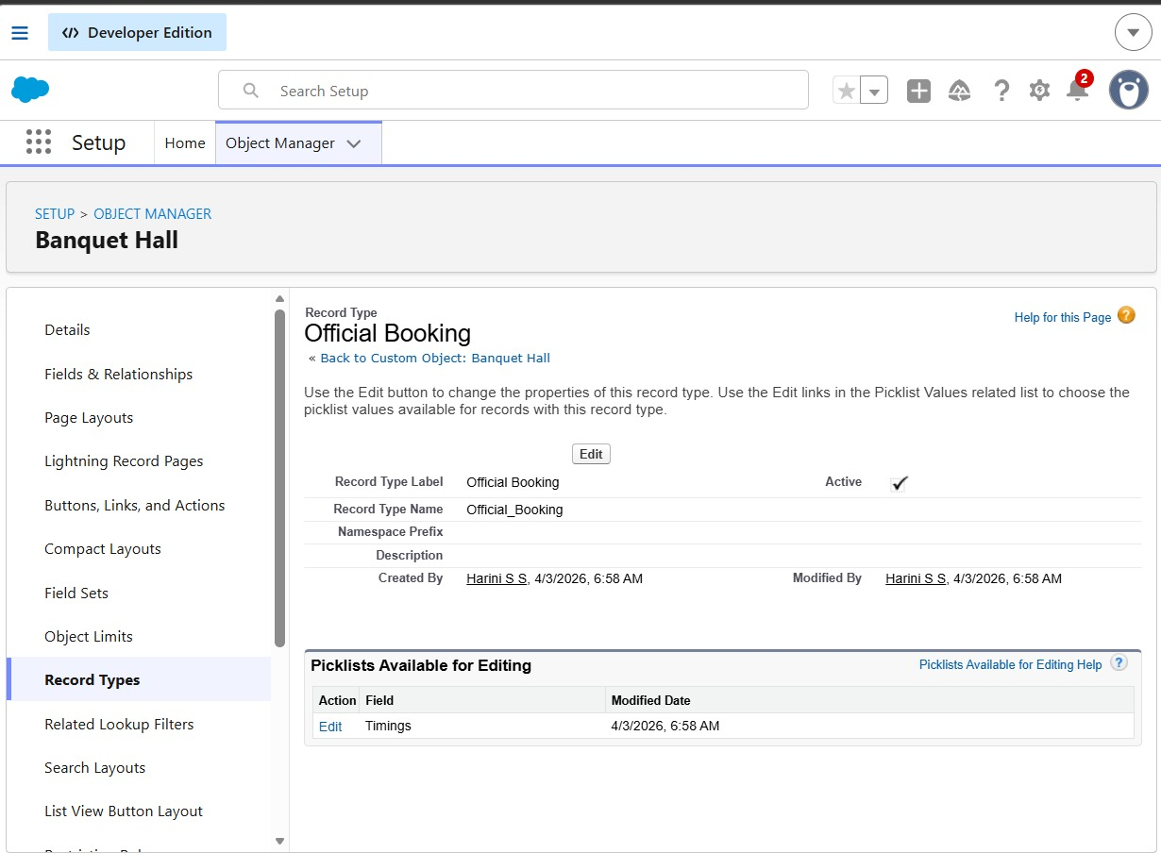

Activity 2: To create a Record Type for Celebrations in Banquet Hall Object
- Go to setup → click on Object Manager → type object name(Banquet Hall) in quick find box→ click on the Banquet Hall object.
- Click on the Record Types. Click on New.
- Enter the details : For Record Types
- Existing Record Types : Master
- Record Type Label : Celebrations
- Record Type Name : Celebrations
Active : Tick checkbox
3.Click on Next
- In Assign Page Layout
- Apply one layout to all profiles : Select Celebrations
- Click on Save

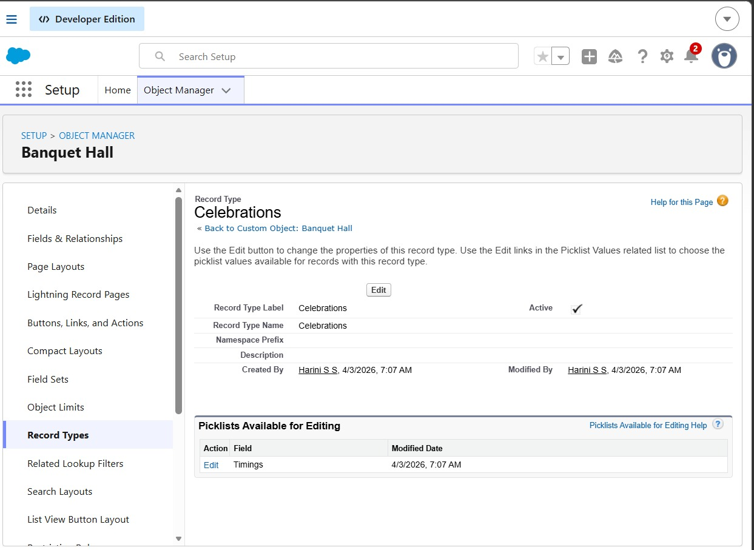
- Milestone 8: Validation rules
Activity 1: To create a validation rule to a Banquet Hall Objec
- Go to setup → click on Object Manager → type object name(Banquet Hall) in quick find box→ click on the Banquet Hall object
- Click on the validation rule → click on New.
- Enter the Rule name as “BookingDateChecking”.
- Select Active
- Insert the Error Condition Formula as : Booking_Date__c <= TODAY()
- Enter the Error Message as “Booking Date must be a future Date”.
- Select the Error location as Field and as Booking Date and click Save.
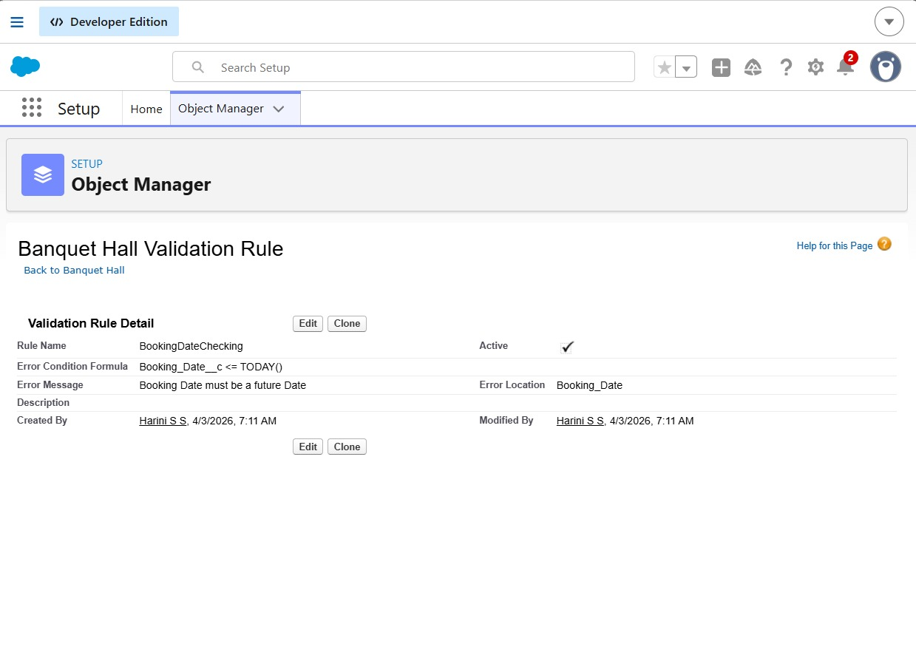

- Milestone 9: Flows
Activity 1 : Create Flow to check whether the same booking date and timings are already available.
Description
- Go to setup → type Flow in quick find box → Click on the Flow and Select the New Flow.
- Select the record Triggered flow.Click on create.
- Under Object select “Banquet Hall”
- Select A record is created
- Set Entry Conditions : None
- Select Fast Field Updates
- Under the record trigger flow click on the “+” icon and select Get Records.
- Enter Label as “ Duplicate Checking for Banquet Hall ”.
- For Object select Banquet Hall
- For Condition Requirements , select All Conditions are Met(AND)
- 10a. For the first condition select as follows:
- Field: Booking_Date__c
- Operator: Equals
- Value: {!$Record.Booking_Date__c}
- 10b. For the second condition select as follows:
- Field: Timings__c
- Operator: Equals
- Value: {!$Record.Timings__c}
- For How many Records to store Select All Records.
- For How to Store Record Data select Choose Automatically Store All Fields. Click on Done.
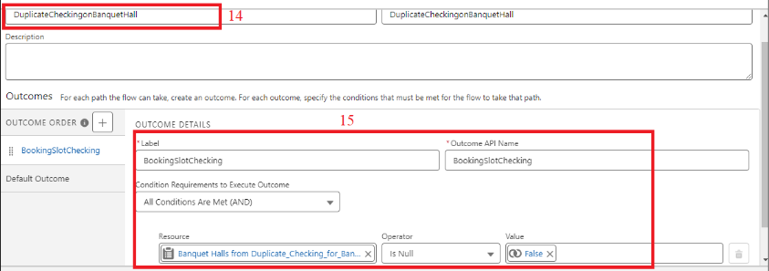

- From the Toolbox drag and drop Decision element.
- Enter the Decision label as “Duplicate Checking on Banquet Hall”.
- For Outcome Details:
- Label : BookingSlotChecking
- Outcome API Name : BookingSlotChecking
- Condition Requirements to Execute Outcome : All Conditions are Met (AND)
- Resource : {!Duplicate_Checking_for_Banquet_Hall}
- Operator : Is Null
- Value : {!$GlobalConstant.False}
- Click Done
- From the Toolbox drag and drop Custom Error Message element.
- Enter the label as “Banquet Hall Booking Error Message”.
- For Where to Show the Error Message: Select In a window on a record page
- Error Message: On {!$Record.Booking_Date__c} , in the {!$Record.Timings__c} the Banquet Hall is not Available for Booking
- Click Done
- Save the flow as “Banquet Hall Booking Availability Checking”
- Activate the flow.
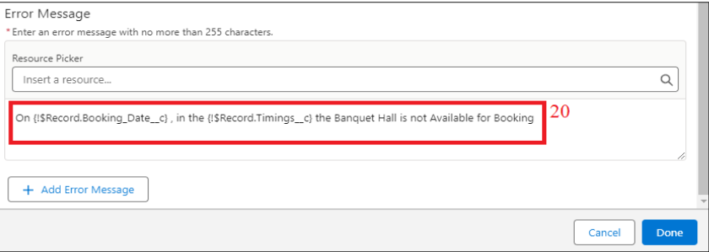

- Milestone 10: Triggers
A Trigger in Salesforce is Apex code that executes before or after a record is created, updated, deleted, or undeleted.
It is used to perform complex or custom logic that can’t be handled by declarative tools like Flows or Validation Rules.

Activity 1 : Create a Trigger for Automated Billing Creation upon Banquet Hall Creation
Step 1 : Login to Salesforce:
Step 2:
i)Navigate to Setup: Once logged in, click on the gear icon ⚙️ (Setup) located at the top-right corner of the page. This will open the Setup menu.
ii)Click on Developer Console: Click on the "Developer Console" option from the Setup menu. This will open the Developer Console in a new browser tab or window.
Step 3:
1) In the Developer Console window, go to the top menu and click on "File".
2)Select New: From the dropdown menu under "File", select "New".
3)Choose Apex Class: In the submenu that appears, select "Apex Class".
Step 4:
i) In the Developer Console window, go to the top menu and click on "File".
ii)Select New: From the dropdown menu under "File", select "New".
iii)Choose Apex Class: In the submenu that appears, select "Apex Trigger". This will open a new Apex Trigger editor tab.

- Milestone 11: Reports
Activity 1: Create a Summary Report
- Click App Launcher
- Select Banquet Hall Booking App
- Click Reports tab
- Click New Report.
- Click the report type as Banquet Halls with Billings, Click Start report.
- Click on Filters and select as follows and click on Apply
- Customize your report, in group rows select – Booking Date, for columns Timings, Total Bill Amount (In this way we are making a Summary Report).
- Click save and run
- Give report name – Banquet Halls with Billings Report
- Click Save
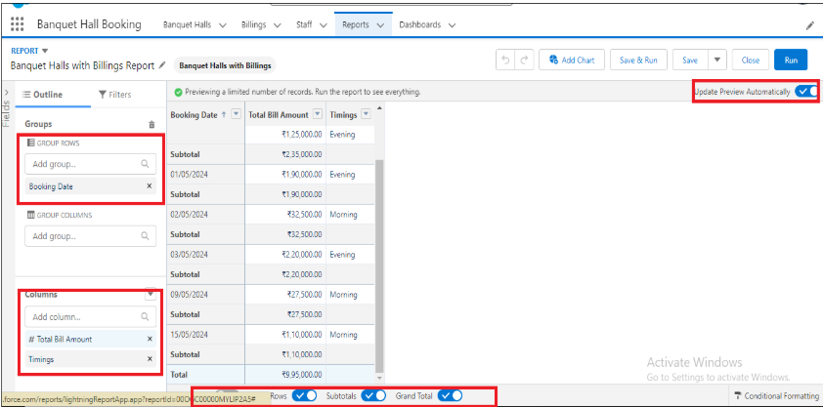

Activity 2: View Report
Description
- Click on App Launcher on the left side of the screen.
- Search Banquet Hall Booking App & click on it.
- Click on Reports Tab.
- Click on Banquet Halls with Billings Report and see records.


- Milestone 12: Dashboards
Activity 1: - Create Dashboard
Description
- Click on the Dashboards tab from the Banquet Hall Booking application.
- Click on the new dashboard.
- Give name - Total Revenue
- Click create
- Give your dashboard a name and click on +widget
- Select the Banquet Halls with Billings Report
- For the data visualization select any of the charts, tables etc. as per your choice/requirement.
- Click add & Click save.
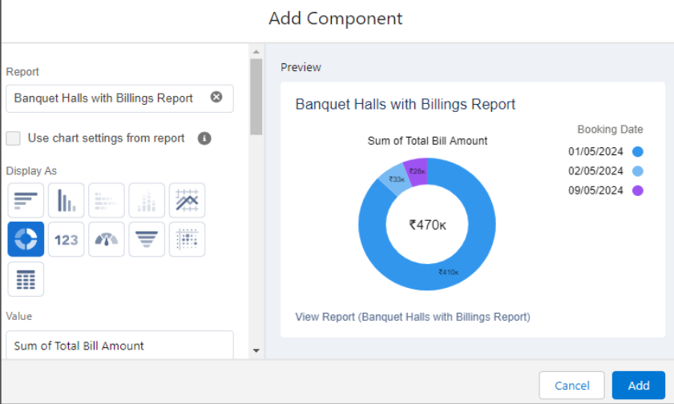

Activity 2: View Dashboard
Description
- Click on App Launcher on the left side of the screen.
- Search Banquet Hall Booking & click on it.
- Click on Dashboard Tab.
- Click on Total Revenue see graph view of records

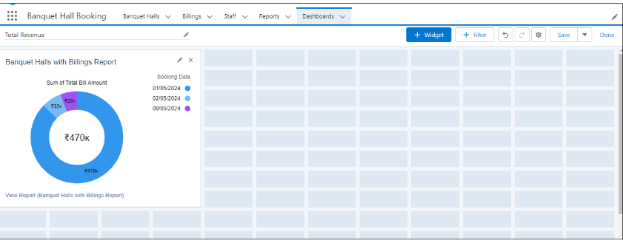

- Conclusion
The Banquet Hall Booking Management System in Salesforce streamlines the entire booking process through a centralized platform.
It enables efficient management of events, client requirements, and additional services like catering, DJ, and decorations.
Automation ensures data accuracy and prevents issues such as double bookings.
The system improves coordination between teams and enhances overall customer experience.
It also provides better visibility into sales and revenue.
Overall, it helps the business operate more efficiently and deliver high-quality event services.

